*Area Frequency and Tie-Line Power Control of An Inter-Tied Power System Using – STATCOM*

*Note: Sub-titles are not captured in Xplore and should not be used

line 1: 1st Surya Vamsi Rampilla   
line 2: Electrical and Electronics Engineering *(of Affiliation)*  
line 3: *Raghu Engineering College (of Affiliation)*line 4: Visakhapatnam, India  
line 5: suryavamsi.456@gmail.com

line 1: Srinivas  
line 2: *Electrical and Electronics Engineering (of Affiliation)*  
line 3: Raghu Engineering College *(of Affiliation)*line 4: Visakhapatnam, India  
line 5:

line 1: Guna Priya Pentakota  
line 2: *Electrical and Electronics Engineering (of Affiliation)*  
line 3: Raghu Engineering College *(of Affiliation)*line 4: Visakhapatnam, India  
line 5:   
  
line 1: 4th prasad porapu  
line 2: *Electrical and Electronics Engineering (of Affiliation)*  
line 3: Raghu Engineering College *(of Affiliation)*line 4: Visakhapatnam, India  
line 5:

***Abstract*—** **Power system is said to be stable when generation is equal to the demand and unstable due to any uncertainties such as sudden change in load demand, fault conditions or any other disturbances; system frequency, voltage will cross its limits. If the system is operating with synchronism frequency is the main factor need to maintain within a permissible limit. This paper demonstrates the single area load frequency control and two-area load and tie line frequency control and tie-line power damping over the steady state value can be controlled by conventional integral controller which makes steady state error is zero but it doesn’t show any impact on the transient behavior of the interconnected system with respect to load changes. FACTS (Flexible AC Transmission) devices like TCSC and STATCOM Can stimulate the tie-line power oscillations exquisitely under sudden occurrence of load changes in any of the area.**

Keywords— two area, tie-line, STATCOM, LFC, AGC

# Introduction

The power system is said to be perfectly balanced, stable only when power generation is equal to the load demand. So, under system balanced criterion; system voltage, frequencies are at their normal operating levels. If load suddenly increases, system fault conditions, disturbances due to system switching, loss of generating unit, failure in the excitation system, failure in turbine governor causes system is to be unstable. If the system operating under unstable or unbalanced condition the system parameters may deviates from its boundaries causes loss in synchronize between control areas. So, we need to control the system parameters under disturbances. One of the main parameters is frequency which shows effect on the power system.

Modern power system network is widely distributed system with large number of generating stations and load centers. As the load demand on the system for electricity has been increasing day to day, several alternative means of energy productions by using renewable energy resources have gained at most importance. The interaction between generating stations and load demand centers has become very complex due to injection of renewable energy even at demand centers. Thus, the problem of load frequency control has become a critical issue in stability of the power system. Classical control schemes, though proving sufficient operation has several limitations like slow operation, improper tuning of parameters, parametric and non-parametric constraints, damping related issues.

For huge scale power systems involving various interconnected control areas, the main aim is to maintain the system frequency and the tie-line power within the permissible limits. For a similar advantage having by Automatic Generation Control (AGC) or Load Frequency Control (LFC) is very significant FACTS devices like static synchronous compensator is one of the basic devices used to reduce harmonics in interconnected power system. In general, these de- vices are shunt devices and are connected in parallel with the circuit to control the power system steady state stability and improves transient stability. STATCOM is one of the key controllers can be founded in two types. One is Voltage Source Controller (VSC) and other one is Current Source Controller (CSC). Fig. 5 Shows the single line diagram of the STATCOM. In economical aspect, VSC are mostly used. Main importance of VSC is its output AC voltage can be controlled and leads to reactive power control. A DC-link capacitor acts as voltage source and it delivers power as per the converter requirement. Similar to the active filters which absorbs harmonics in the system to retain system frequency. sometimes these STATCOM is also used for injection of current to maintain the system active powers within limits.

# Area load — frequency control

Figure.1 shows Generic load frequency control mechanism. Change in load, make variations in electrical torque of the generator, and this variation results in a mismatch between the mechanical and electrical torque, resulting in speed variations. The governor will sense the variation in speed and adjust the valve position to increase /decrease steam flow from the furnace toward the turbine to balance the torque mismatch (primary loop). This balance is rarely performed at the rated frequency. Therefore, “to achieve the rated frequency of the system and recompense for power imbalance”, the governor’s set point is changed by the actions of an automatic load frequency control controller whose decisions are taken promptly and have to offer strong power system operation under several different contingency situations.

Figure1. Generic load frequency scheme

## Single-area load frequency control

Single control area is nothing but area in which all the generators are closely coupled together, synchronized to control the output power of all the generators to maintain the scheduled frequency of the system within a permissible limit. In such an electric area all the generators whose speeds increasing and decreasing simultaneously such coherent area can be called as control area. During in both dynamic and static conditions the frequency response is same.

A single control area consisting of turbine, governor, electric generators whose transfer functions are indicated in block diagram as shown in Figure.2, where Ki is the integral controller gain constant, $K_{g}$, $K_{t}$, $K_{p}$ are the governor, turbine, generator gain constants, And $T_{g}$, $T_{t}$, $T_{p}$ the governor, turbine, generator time constants. And $∆P_{d}$ is the deviation in load demand $∆f$ be the change in area Frequency with respect to load change.

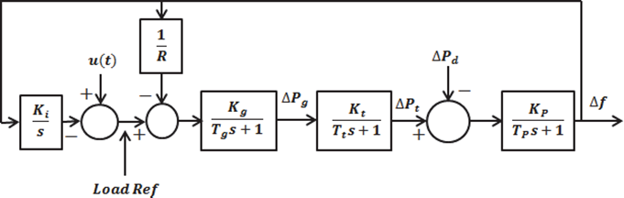Figure 2. Single area load frequency control block diagram

## Load frequency control — single area

Figure.3 indicates the frequency response of the single area load - frequency control. the steady state frequency deviations due to change in two parameters one is change in load other one is change in speed changer setting. In this the main objective of the speed changer setting is to bring the steady state system frequency to the scheduled frequency by adjusting itself when the system subjected to unacceptable dynamic system frequency deviations. When there is a sudden change in load then speed changer setting can be automatically adjusted by observing the changes is frequency. A signal $∆f$ can be feedback to input through integrator to the speed changer. Now the system can be modified into proportional plus integral controller which gives steady state error to be zero.

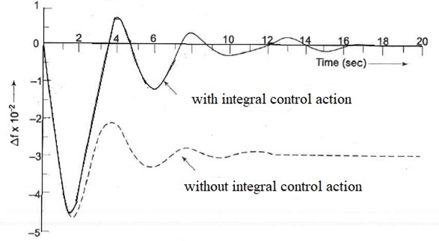

Figure 3. Single control area load frequency response

## Load frequency control — Two area

A number of control areas are when interconnected forms a large power system. In case of two, single control areas are inter-tied there may be deviation in the entire system frequency need to be control knows as two area load frequency control and, are inter-tied by line called tie-line whose frequency, tie line power are need to be constant under normal operating conditions. If any one of area load changes suddenly, entire power system frequency and tie line power also changes. Fig.4 shows interconnected system block diagram.

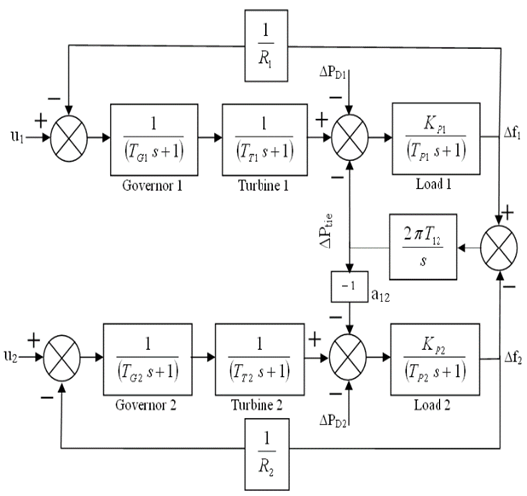Figure 4. Single line diagram of interconnected system

# Formulation

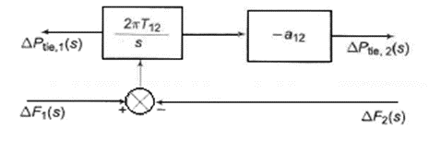

From Area 1, to Area 2 change in tie line power

🡪(1)

From Area 2, to Area 1 change in tie line power

🡪(2)

# Controller

STATCOM:

Static synchronous compensator (SATCOM), or it is also known as a static synchronous generator can be operated as static VAR compensator connected in parallel, whose capacitive and inductive output currents can control which are not dependent of a system voltage (AC)

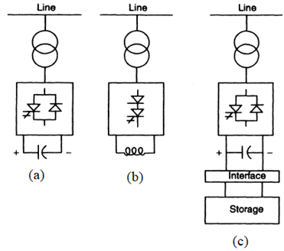

Figure 5. STATCOM single line diagram

Figure.6 indicates that simple operating principle of STATCOM which is connected in shunt to the power line through the magnetic circuit. In general, STATCOM’s are operated with power electronics devices. From the figure Iq and Es be the STATCOM current and voltage, Idc, Vdc are the capacitor current and voltages. And Et be the utility terminal voltage. If Es>Et it supplies reactive power and Es<Et it absorbs reactive power.

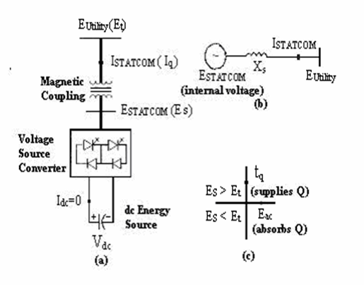Figure 6. simple operating principle

1. System Parameters

|  |  |
| --- | --- |
| Ki (integrator gain constant) | 0.09 |
| Ksg (governor gain constant) | 100 |
| Kt (turbine gain constant) | 1 |
| Kps (generator gain constant) | 1 |
| R(speed regulator constant) | 3 |
| B(biasing coefficient) | 0.425 |
| ΔPd (percentage change in load) | 1% |
| Tsg (governor time constant) | 0.4 |
| Tt (turbine time constant) | 0.5 |
| Tps (generator time constant) | 20 |
| T12, T21 (synchronizing coefficient) | 1 |

# Simulation results

## Two area load frequency control without controller

Simulation block diagram of two area load frequency control, designed in simulation using Figure.3 and run the simulation in MATLAB with the help of parameters provided in table.1.and the simulation gives the results for change in frequency and tie line power with the change in load. Figure.6 indicates the two-area load frequency control without any controller with the 10 % change(increase) in load in area.1 shows the effect not only on the frequency of area.1 but also it shows the impact on area.2 frequency and tie line power. there is some instability in both transient and steady state frequency response of area 1,2 and tie line power Ptie 1,2. Figure.7 shows the tie-line power having a greater number of oscillations due to sudden change in load

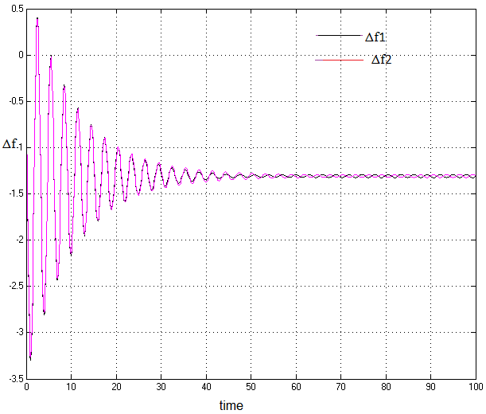Figure 7. Two area load frequency without controller

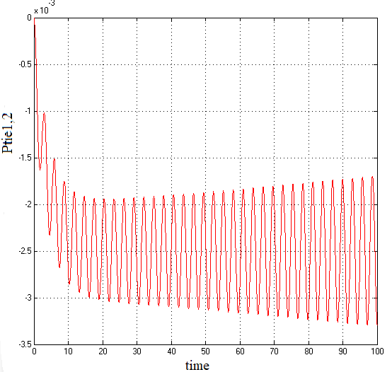Figure 8. Tie-line power without controller

## Two-area load frequency control with integral controller

The main application of controller with integral controller is to bettering the steady – state response. In integral controller as Ki value increases the magnitude also increases and due to pole at origin which makes steady state error equals to zero. Figure.8 indicates two- area interconnected system frequency response. system whose steady state error makes to zero even with sudden increase in load to 10% and Figure.9 shows the tie-line power of interconnected system whose oscillations can be reduced about its final equilibrium point.

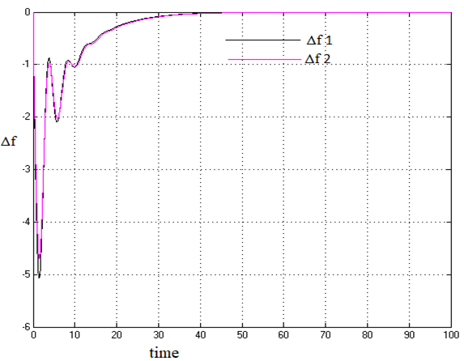Figure 9. Two area load frequency control with integral controller

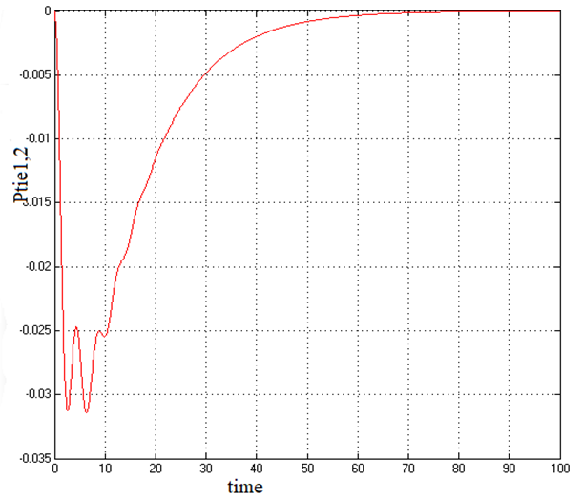

Figure 10. Two - area load frequency control, tie line power with integral controller

## Two-area load frequency control with STATCOM controller

Integral controller only improves the steady state response but it doesn’t show any effect on the transient response. and the STATCOM is used to improves both the transient response and inject the reactive power and absorbs so that it reduces the power oscillation damping’s of the tie-line power with sudden change in load. Figure.11 shows the two-area load frequency control with STATCOM reduce both steady state error to zero and Figure.12 shows two-area load frequency control tie line power with STATCOM which reduce the both steady state and transient oscillations tie-line power.

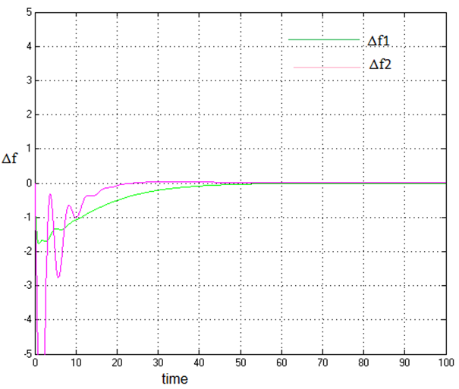

Figure 11. Two area load frequency control with STATCOM controller

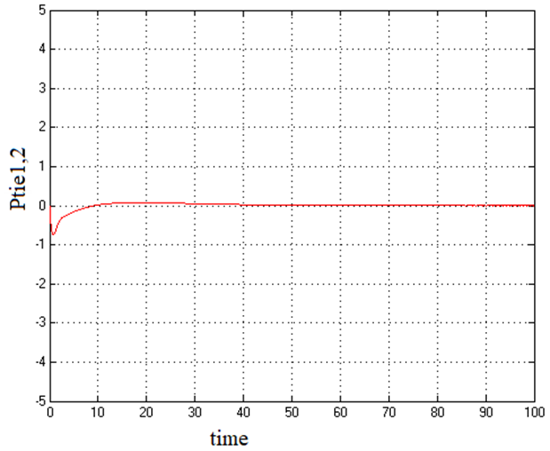

Figure 12. Two - area load frequency control, tie line power with STATCOM

##### Conclusion

In this paper, two area load frequency control was modelled using MATLAB simulation for controlling area load frequency and tie line power which changes due to sudden change(increase) in load. Integral controller is used to improve the steady state response which makes steady state error is equals to zero and to improves the damping oscillations in tie line power the best controllers are FACTS devices. STATCOM is one of the basic FACTS device which is connected in series to the tie line to make the steady state error to zero and reduce the tie line power oscillation in transient state.

##### References

1. Kundur P.: ”Power stability and control”, Mcgraw Hill, 2009
2. Concordia, C., & Kirchmayer, L. K. (1954). Tie-Line Power and Frequency Control of Electric Power Systems - Part II [includes discussion]. Transactions of the American Institute of Electrical Engineers. Part III: Power Apparatus and Systems, 73(2), 133–146.
3. Kirchmayer, L.K: Economic control of interconnected systems. (1960). Journal of the Franklin Institute, 269(6), 492–493.
4. Jaleeli, N., VanSlyck, L. S., Ewart, D. N., Fink, L. H., & Hoffmann, A. G. (1992). Understanding automatic generation control. IEEE Transactions on Power Systems, 7(3), 1106–1122.
5. Das, D., Kothari, M. L., Kothari, D. P., & Nanda, J. (1991). Variable structure control strategy to automatic generation control of interconnected reheat thermal system. IEE Proceedings D Control Theory and Applications, 138(6), 579.
6. Chan, W.-C., & Hsu, Y.-Y. (1981). Automatic generation control of interconnected power systems using variable-structure controllers. IEE Proceedings C Generation, Transmission and Distribution, 128(5), 269.
7. Pal, B. C., Coonick, A. H., & Macdonald, D. C. (n.d.). Robust damping controller design in power systems with superconducting magnetic energy storage devices. 2000 IEEE Power Engineering Society Winter Meeting. Conference Proceedings (Cat. No.00CH37077).
8. Abraham, R. J., Das, D., & Patra, A. (2007). Effect of TCPS on oscillations in tie-power and area frequencies in an interconnected hydrothermal power system. IET Generation, Transmission & Distribution, 1(4), 632.
9. Bikash Pal and Balarko Chaudhuri. Robust Control in Power Systems. (2005). Power Electronics and Power Systems.
10. Hingorani,N.G and Gyugi,L.:”Understanding FACTS” (IEEE Press,2000)
11. Pal,B.C, Rehantz,C. and Zhang, X.P:”Flexible AC Transmission Systems: Modelling and Control”,(Springer,2006)
12. Kimbark, E.W:”Improvement of System stability by switched series capacitors”,IEEE Trans. Power Apparatus Syst. 1966,PAS-85,(2), pp.180-188
13. Rajaraman et al, Computing the damping of sub-synchronous oscillations due to a TCSC, IEEE Trans on Power Del,Vol.11,No.2,April 1996.
14. Jonas Persson, Lennart Soder:”Validity of a linear Model of a thyristor-controlled series capacitor for Dynamic Simulations”, in Proc.14th Power Systems Computation Conference, June 24th - 28th,2002,Sevilla,Spain.
15. P. Mattavelli,G.C Verghese,A.M Stankovic,”Phasor dynamics of Thyristor Controlled Series Capacitor Systems”,IEEE Summer Meeting 532-2 PWRS,1996.
16. H.A.Othman, L.Angquist, et al.,:”Analytical Modeling of Thyristor- Controlled Series Capacitors for SSR studies”,IEEE Trans. Power Systems,Vol.11,No.1,1996,pp.119-127.
17. John J Paserba,Nicholas W.Miller et al,”A thyristor Controlled Series Compensation Model for Power System Stability Analysis”,IEEE Trans.Power Delivery,Vol.10,No.3,1995,pp.1471-1478.
18. Saadat,H.:”Power System Analysis”, McGraw Hill,USA,1999.
19. Ibraheem, Prabhat Kumar and D. P. Kothari “Recent Philosophies of Automatic Generation Control Strategies in Power Systems”, IEEE Trans. on Power System, Vol. 20, No.1, pp. 346-357, Feb 2005.
20. K. C. Divya and P. S. N. Rao, “A Simulation Model for AGC Studies of Hydro-Hydro Systems” Electrical Power and Energy Systems 27, pp.335-342, 2005
21. R.J. Abraham, D.Das and A.Patra: “AGC study of a Hydrothermal system with SMES and TCPS”, European Transactions on Elecrical Power, Vol.19, pp.487-498, April 2009.
22. IEEE Committee Report: ‘Dynamic models for steam and hydro turbines in power system studies’, IEEE Trans. Power Appar. Syst., 1973, 92, (6), pp. 1904– 1915.
23. N. Cohn, Control of Generation and Power Flow on Interconnected Systems, New York, John Wiley,1986.

line 1: 1st Suryavamsi Rampilla   
line 2: *Electrical and electronics engineering(of Affiliation)*  
line 3: *Raghu engineering college(of Affiliation)*line 4: Visakhapatnam, India  
line 5: suryavamsi.456@gmail.com  
  
line 1: 2nd Srinivas  
line 2: *Electrical (of Affiliation)*  
line 3: *name of organization (of Affiliation)*line 4: City, Country  
line 5: email address or ORCID  
  
line 1: 3rd Given Name Surname  
line 2: *dept. name of organization (of Affiliation)*  
line 3: *name of organization (of Affiliation)*line 4: City, Country  
line 5: email address or ORCID  
  
line 1: 4th Given Name Surname  
line 2: *dept. name of organization (of Affiliation)*  
line 3: *name of organization (of Affiliation)*line 4: City, Country  
line 5: email address or ORCID